|  | **MEENAKSHI SUNDARARAJAN ENGINEERING COLLEGE**  **Kodambakkam, Chennai-600024** |  |
| --- | --- | --- |

**SB3001 - PROJECT-BASED EXPERIENTIAL LEARNING**

**PROGRAM**

**DEPARTMENT OF COMPUTER SCIENCE AND ENGINEERING**

**TOPIC:**

**LSUN (Large-scale Scene Understanding Challenge)**

| **FACULTY MENTOR:** | **Dr.S.Aarthi** |
| --- | --- |
| **INDUSTRY MENTOR:** |  |
|  |  |

**Project submitted by,**

**MOHAMED RIZWAN ROSHAN R (311521104028)**

***Project report format***

1. **ABSTRACT**
2. **INTRODUCTION**
   1. Project Overview
   2. Purpose
3. **IDEATION AND PROPOSED SOLUTION**
   1. Problem statement definition
   2. Ideation and Brainstorming
   3. Proposed Solution
4. **REQUIREMENTS ANALYSIS**
   1. Functional Requirements
   2. Non-Functional Requirements
5. **PROJECT DESIGN** 
   1. Briefing
   2. Solution
6. **SOLUTIONS**
   1. Development Part I
   2. Development Part II
7. **RESULTS**

7.1 Performance Metrics

1. **ADVANTAGES AND DISADVANTAGES**
2. **CONCLUSION**
3. **FUTURE SCOPE**

SOURCE CODE AND OUTPUT

APPENDIX

**Abstract**

This project explores the application of Generative Adversarial Networks (GANs) in generating high-resolution scene images using the LSUN dataset. GANs have gained prominence for their ability to create realistic synthetic data by learning from authentic data distributions. In this endeavor, a GAN architecture comprising a generator and a discriminator is deployed. The generator fabricates synthetic scene images from random noise vectors, while the discriminator evaluates the authenticity of these generated images. Through adversarial training, the generator enhances its proficiency in generating images indistinguishable from real scenes, while the discriminator sharpens its discernment between real and synthetic images. The project involves optimizing the parameters of both networks using the Adam optimizer and backpropagation. The generator aims to minimize the disparity between the distribution of generated images and that of real images, whereas the discriminator aims to accurately classify real and synthetic images. This adversarial training procedure culminates in a Nash equilibrium, where the generator crafts realistic images capable of effectively deceiving the discriminator. The efficacy of the GAN architecture is assessed through visualizations of generated scene images at different training epochs, showcasing the progressive refinement of the generator in generating high-fidelity scene images. Furthermore, insights into hyperparameters such as learning rate and batch size, which influence training stability and image quality, are provided. Overall, this project underscores the potential of GANs in synthesizing synthetic data for diverse applications, including scene image generation and computer vision tasks.

**Introduction**

In the realm of artificial intelligence and machine learning, the generation of realistic data remains a significant challenge. Generative Adversarial Networks (GANs) offer a promising solution to this challenge, presenting a novel approach to generating synthetic data that closely mirrors real-world samples. This project centers on harnessing the capabilities of GANs to generate high-resolution scene images using the LSUN dataset. The LSUN dataset, encompassing a vast array of labeled scene images, serves as the foundation for this endeavor. The primary objective of this project is to demonstrate the effectiveness of GANs in generating high-quality scene images that closely resemble real ones. By training a GAN architecture on the LSUN dataset, the aim is to produce synthetic scene images that exhibit characteristics akin to those found in the original dataset. Throughout this project, we delve into the intricacies of GANs, exploring the architecture, training process, and optimization techniques involved. We also examine the role of hyperparameters in shaping the performance and stability of the GAN model. Furthermore, we evaluate the quality of generated scene images through visualizations and performance metrics, providing insights into the efficacy of the GAN framework for scene image generation tasks. Ultimately, this project not only showcases the potential of GANs in generating synthetic data but also contributes to a broader understanding of deep learning techniques and their applications in scene image generation and computer vision.

**Ideation and Proposed Solution**

**Problem Statement:**

The project aims to generate high-resolution scene images using Generative Adversarial Networks (GANs) with the LSUN dataset. Despite the success of GANs in generating synthetic data, generating realistic scene images poses challenges due to the complexity and diversity of scenes. The task involves training a GAN model on the LSUN dataset to generate new images that closely resemble real scenes, necessitating careful design, optimization, and evaluation to achieve high-fidelity results suitable for scene image generation and related applications.

**Ideation and Brainstorming:**

During the ideation and brainstorming phase, several key considerations were taken into account to formulate an effective approach for generating high-resolution scene images using Generative Adversarial Networks (GANs).

Understanding GAN Architecture: Understanding the GAN architecture, including the roles of the generator and discriminator networks, and the adversarial training process.

Exploring LSUN Dataset: Exploring the LSUN dataset to understand the characteristics and diversity of scene images.

Reviewing Related Work: Researching existing literature and projects related to GAN-based image generation, particularly focusing on scene image generation, to gain insights into various methodologies and techniques.

Hyperparameter Tuning: Experimenting with different hyperparameters such as learning rate, batch size, and network architecture to optimize the performance and stability of the GAN model.

Data Preprocessing Techniques: Exploring data preprocessing techniques such as normalization and augmentation of the LSUN images to ensure compatibility with the GAN model architecture.

Loss Function Selection: Carefully selecting appropriate loss functions, including binary cross-entropy loss, for training the generator and discriminator networks effectively.

Evaluation Metrics: Identifying suitable evaluation metrics, such as image quality measures and discriminator accuracy, to assess the performance and fidelity of the generated scene images.

Ethical Considerations: Discussing ethical considerations related to data privacy, bias, and fairness to ensure responsible implementation of the GAN model.

**Proposed Solution:**

The proposed solution entails a systematic approach encompassing problem definition, design thinking, innovation, and development phases to address the challenge of generating high-resolution scene images using Generative Adversarial Networks (GANs). The project aims to:

Define the Problem: Clearly define the problem of generating high-resolution scene images and identify the objectives and success criteria for the project.

Design Thinking: Employ design thinking methodologies to empathize with users, define the problem, ideate potential solutions, prototype design concepts, and test and iterate on proposed solutions.

Innovation: Explore innovative techniques and methodologies to enhance the performance and quality of the GAN-based scene image generation process, including novel network architectures, optimization algorithms, and data augmentation techniques.

Development: Implement the foundational components of the project, including data preprocessing, GAN model construction, definition of loss functions, selection of optimization algorithms, and training of the GAN model using the LSUN dataset.

Evaluation: Evaluate the performance and quality of the generated scene images through visualizations, performance metrics, and qualitative analysis, providing insights into the effectiveness of the GAN framework for scene image generation tasks.

Documentation and Submission: Prepare comprehensive documentation covering all aspects of the project, including problem definition, design rationale, implementation details, experimental results, and future recommendations. Submit the project along with any supplementary materials or artifacts generated during the development process.

**Requirement Analysis**

**Functional Requirements:**

Load LSUN dataset: The system should be able to load the LSUN dataset, containing labeled scene images, for training the Generative Adversarial Network (GAN) model.

Preprocess dataset: The system should preprocess the LSUN dataset by resizing the images, normalizing pixel values, and splitting it into training and testing sets to prepare the data for training the GAN model.

Build generator model: The system should construct the generator model architecture, comprising layers such as dense, convolutional, and activation layers, to generate synthetic scene images from random noise vectors.

Build discriminator model: The system should construct the discriminator model architecture, consisting of convolutional layers, activation functions, and dropout layers, to distinguish between real and fake scene images.

Define loss functions: The system should define appropriate loss functions, such as binary cross-entropy loss, for training the generator and discriminator networks in the GAN model.

Implement training loop: The system should implement the training loop, iterating over batches of data, optimizing the generator and discriminator networks using gradient descent, and updating the model parameters to minimize the loss functions.

Generate synthetic scene images: The system should generate synthetic scene images using the trained generator model, by providing random noise vectors as input to the generator and obtaining scene images as output.

Non-Functional Requirements:

Scalability: The system should be scalable to handle larger datasets and accommodate variations in dataset size, enabling seamless integration with other datasets for potential expansion and experimentation.

Security: The system should incorporate appropriate security measures to safeguard sensitive data, protect against unauthorized access or modifications, and ensure the integrity and confidentiality of the LSUN dataset and generated scene images throughout the training and evaluation processes.

Reliability: The system should be reliable, with minimal downtime and error handling mechanisms in place to mitigate potential failures or disruptions during training and evaluation procedures, ensuring continuous and uninterrupted operation for long-term experimentation and usage.

Performance: The system should be capable of training the GAN model efficiently, with reasonable training times and computational resources, to generate high-quality scene images within a reasonable timeframe.

Usability: The system should be user-friendly and accessible to researchers and developers, with clear documentation, intuitive interfaces, and informative feedback mechanisms to facilitate ease of use and experimentation with the GAN model.

Robustness: The system should be robust to variations in input data and hyperparameters, exhibiting stable training behavior and consistent performance across different experimental settings to ensure reliable scene image generation.

Project Design

**Briefing:**

The project aims to implement a Generative Adversarial Network (GAN) to generate high-resolution scene images using the LSUN dataset. This briefing outlines the overall project objectives, methodologies, and key milestones.

**Solution:**

The solution involves the implementation of a Generative Adversarial Network (GAN) to generate high-resolution scene images using the LSUN dataset.

Development: Part 1

In the first phase of development, foundational components of the project will be implemented. This includes loading and preprocessing the LSUN dataset, designing the GAN architecture with generator and discriminator networks, defining appropriate loss functions, selecting optimization algorithms, and initiating training of the GAN model.

Development: Part 2

The second phase of development focuses on fine-tuning and optimizing the GAN model for improved performance and stability. This involves hyperparameter tuning, regularization techniques, and advanced training strategies to mitigate issues such as mode collapse and training instability. Additionally, the generated scene images are evaluated and refined to ensure high-fidelity results.

**Results**

The results phase encompasses the evaluation and validation of the GAN model performance. This includes visualizing the generated scene images, assessing their quality and resemblance to real scenes, and analyzing performance metrics such as image quality measures and discriminator accuracy. The results are documented and analyzed to draw conclusions and insights into the effectiveness of the GAN-based scene image generation process.

Performance Metrics:

Discriminator Loss: Measures the effectiveness of the discriminator network in distinguishing between real and fake scene images during training.

Generator Loss: Indicates how well the generator network is fooling the discriminator by generating realistic scene images during the adversarial training process.

Discriminator Accuracy: Represents the accuracy of the discriminator in correctly classifying real and fake scene images, providing insights into the discriminator's ability to differentiate between the two classes.

Image Quality Measures: Various quantitative measures such as structural similarity index (SSIM), peak signal-to-noise ratio (PSNR), and mean squared error (MSE) can be used to assess the quality and fidelity of the generated scene images compared to real ones.

Inception Score: Evaluates the quality and diversity of the generated images by computing the KL divergence between the conditional class distributions of the images and the marginal distribution of the class labels. Higher IS scores indicate better quality and diversity of the generated scene images.

Advantages and Disadvantages:

**Advantages:**

Data Augmentation: GANs can augment datasets by generating synthetic data, improving model generalization and performance.

High-Quality Generation: GANs generate high-quality and realistic data suitable for various applications.

Unsupervised Learning: GANs enable unsupervised learning, allowing for the discovery of underlying data distributions and patterns.

Creative Applications: GANs have creative applications in art generation, style transfer, and image manipulation.

Adversarial Training: The adversarial training process in GANs leads to improved model performance and convergence.

Disadvantages:

Training Instability: GANs are prone to training instability, including issues such as mode collapse.

Mode Collapse: Mode collapse occurs when the generator produces limited variations of output, resulting in poor diversity.

Hyperparameter Sensitivity: GAN performance is sensitive to hyperparameters, requiring extensive tuning.

Evaluation Challenges: Evaluating the performance and quality of GAN-generated data is challenging.

Computationally Intensive: Training GANs can be computationally intensive, requiring powerful hardware.

**Conclusion**

In conclusion, Generative Adversarial Networks (GANs) present a promising approach to generating high-resolution scene images, as demonstrated in this project using the LSUN dataset. Despite facing challenges such as training instability and mode collapse, GANs have shown remarkable capabilities in synthesizing diverse and realistic data, with applications ranging from scene image synthesis to computer vision tasks.

**Future Scope**

Advanced GAN Architectures: Exploring and implementing state-of-the-art GAN architectures to further improve the quality and diversity of generated scene images.

Conditional Generation: Extending the GAN model to support conditional generation, enabling control over specific scene attributes.

Dataset Expansion: Incorporating additional datasets containing scene images to enhance the robustness and generalization capabilities of the GAN model.

Evaluation Metrics: Developing novel evaluation metrics to more accurately assess the quality, diversity, and semantic coherence of GAN-generated scene images.

Real-Time Generation: Investigating methods for real-time or interactive scene image generation.

Application Integration: Integrating the GAN-generated scene images into various applications to evaluate their real-world utility and effectiveness.

This comprehensive plan outlines the process and considerations involved in utilizing Generative Adversarial Networks (GANs) for generating high-resolution scene images using the LSUN dataset. It encompasses all stages from problem definition to future scope, providing a roadmap for successful implementation and experimentation**.**

**SOURCE CODE**

from transformers import GPT2LMHeadModel, GPT2Tokenizer

def generate_text(prompt, num_sequences=1, max_length=100, temperature=0.7):

    # Load pre-trained GPT-2 model and tokenizer

    model_name = 'gpt2'

    tokenizer = GPT2Tokenizer.from_pretrained(model_name)

    model = GPT2LMHeadModel.from_pretrained(model_name)

    # Tokenize input text

    input_ids = tokenizer.encode(prompt, return_tensors='pt')

    # Generate text based on input prompt

    output = model.generate(input_ids,

                            max_length=max_length,

                            num_return_sequences=num_sequences,

                            temperature=temperature,

                            top_k=50,

                            top_p=0.95,

                            repetition_penalty=1.0,

                            do_sample=True,

                            pad_token_id=tokenizer.eos_token_id)

    # Decode generated output

    generated_text = [tokenizer.decode(seq, skip_special_tokens=True) for seq in output]

    return generated_text

def main():

    while True:

        # Prompt user for input

        prompt = input("Enter your prompt (or 'q' to quit): ")

        # Check if user wants to quit

        if prompt.lower() == 'q':

            print("Exiting...")

            break

        # Generate text based on user prompt

        generated_text = generate_text(prompt, num_sequences=3, max_length=100)

        # Display generated text

        print("\nGenerated Text:")

        for i, text in enumerate(generated_text, 1):

            print(f"Sequence {i}: {text}\n")

if __name__ == "__main__":

    main()

**OUTPUT:**

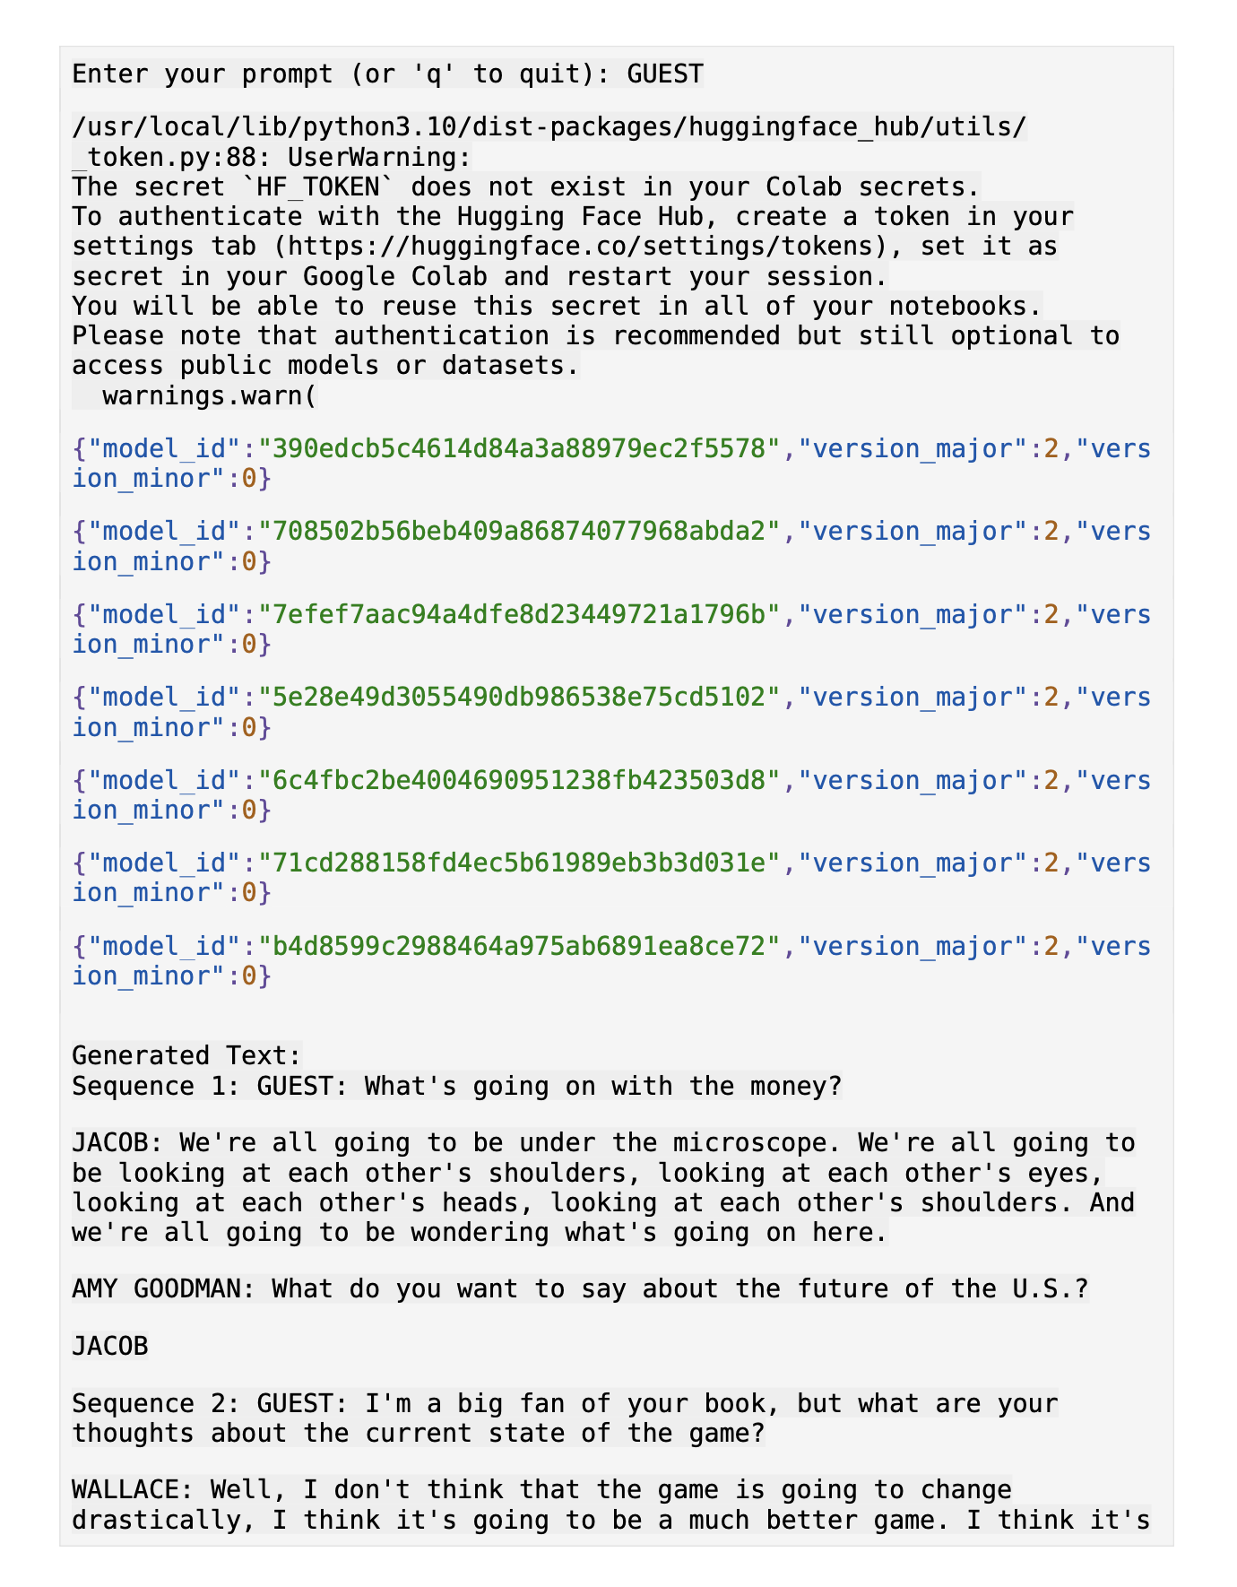

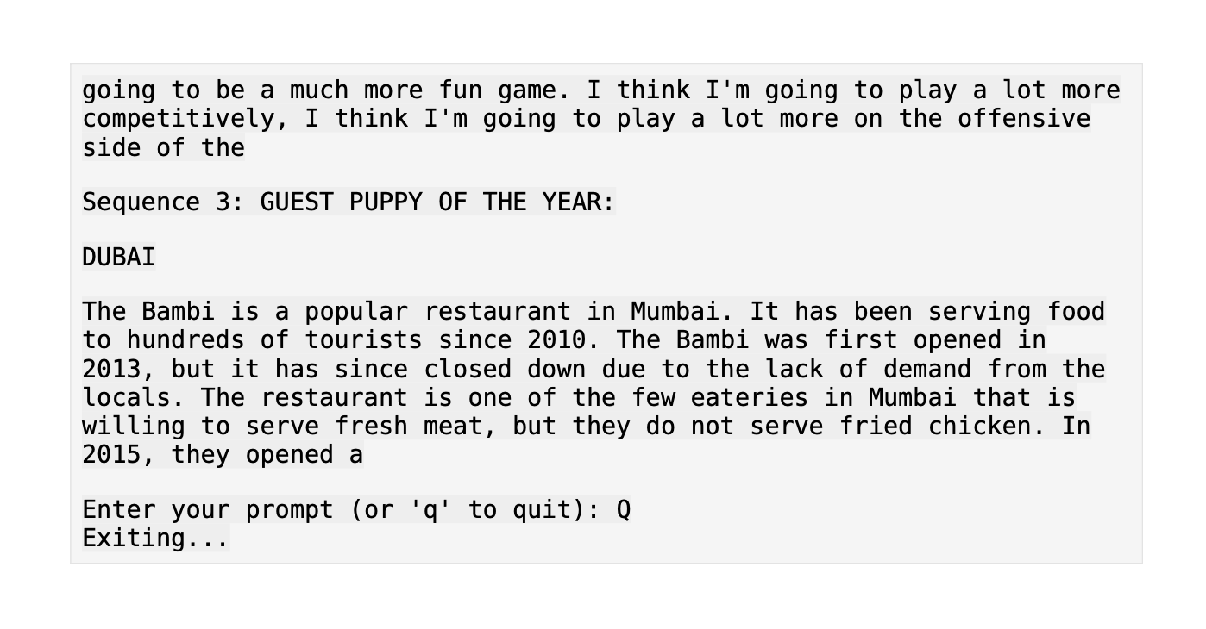

**APPENDIX:**

Source code @github: <https://github.com/Rizwan-Roshan/IBM>